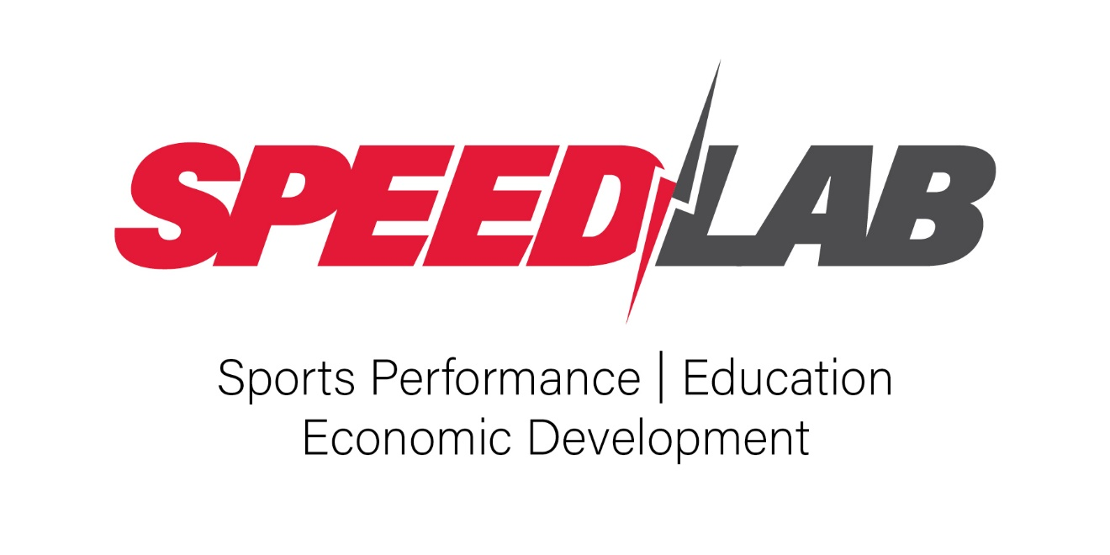
STRENGTH & CONDITIONING COACH

Strength and Conditioning Coaches are performance professionals who apply principles of exercise science to improve athletic ability, reduce injury risk, and enhance physical readiness. Although S&C coaches work in a variety of settings, including collegiate athletics, professional sports, tactical and military programs, private facilities, and clinical rehabilitation environments, their core responsibilities remain consistent.

Common Work Settings & Career Paths:
- Collegiate & Professional Sports – S&C coaches in these settings develop and implement sport-specific training programs, manage in-season and off-season periodization, and collaborate with athletic trainers, dietitians, and coaching staff to optimize performance and reduce injury risk.
- Military & Tactical Performance – Coaches working with military, law enforcement, or first responders focus on improving mission-readiness, job-specific performance, and long-term injury resilience. These roles often require adapting programs to tactical tasks and collaborating with interdisciplinary human performance teams.
- Private Sector & Sports Performance Facilities – In private facilities, S&C coaches train a diverse client base, including youth athletes, elite professionals, and general populations. Emphasis is placed on movement quality, long-term athletic development, and return-to-play support.
- Clinical & Rehabilitation Settings – In clinical environments, S&C coaches work alongside medical providers to bridge the gap between rehabilitation and performance. They assist with reconditioning programs for individuals recovering from injury or surgery and support functional progression toward return to sport or activity.

Entry-Level: Strength & Conditioning Coach Intern
These roles are designed for students or recent graduates pursuing practical experience in high-performance training environments. Interns assist with training sessions, observe program design, and support daily operations under the supervision of certified coaches.
- Job Responsibilities – Assist with warm-ups, training setups, basic athlete supervision, and equipment maintenance; observe testing protocols and recovery sessions; maintain equipment and facility cleanliness.
- Education – Bachelor’s degree in progress or recently completed in Exercise Science, Kinesiology, or a related field.
- Licenses/Certifications – Working toward CSCS, SCCC, or CSCCA; CPR/AED often required.
- Preferred Experience – Experience as a student-athlete or strength intern; familiarity with lifting technique, basic monitoring tools, and professional communication in a performance setting.
Mid-Level: Assistant Strength & Conditioning or Performance Coach
These roles are for certified professionals responsible for independently managing strength and conditioning programs for assigned teams or athletes. Mid-level coaches serve as primary program leads and collaborate with sport coaches, athletic trainers, and sport scientists to support team goals.
- Job Responsibilities – Design and implement sport-specific training; conduct performance testing; monitor athlete workloads using GPS or velocity tools; maintain documentation; assist in return-to-play protocols; supervise interns or support staff.
- Education – Bachelor’s degree required; Master’s preferred.
- Licenses/Certifications – CSCS and/or CSCCA required; CPR/AED; USAW or similar strength-related certifications preferred.
- Preferred Experience – 2–5 years coaching experience; proficiency with athlete monitoring tools (e.g., Force Plate & GPS); strong understanding of Olympic lifting, periodization, and injury prevention.
Elite-Level: Director of Sports Performance / Head Strength & Conditioning Coach
These leadership roles oversee the strategic direction and daily operations of strength and conditioning programs. Coaches at this level supervise staff, manage department logistics, and align physical preparation systems with organizational performance goals.
- Job Responsibilities – Lead department operations and staff; develop long-term periodization plans; integrate injury prevention and performance technology; collaborate with medical and coaching staff; manage budget, scheduling, and compliance.
- Education – Master’s degree required.
- Licenses/Certifications – CSCS, SCCC, or CSCCA required; CPR/AED; additional credentials in sport science, recovery, or nutrition valued.
- Preferred Experience – 5–10+ years in strength & conditioning; experience leading staff in collegiate, professional, or tactical environments; demonstrated expertise in force plates, GPS systems, and athlete management software; history of program development and interdisciplinary collaboration.

