Ford Transit Van: Need 2 Know
Reverse Camera:
The reverse camera is located in the left corner of the rearview mirror (circled in the left photo below). However, as useful as the reverse camera can be there are times, more often than not, the reverse camera will turn off or just not turn on at all (circled in the right photo below). It is important to not solely rely on the reverse camera and make sure the side mirror on the van is in a comfortable position for you (the driver) to see your blind spots. It must be noted that even with the full operation of the reverse camera it still cannot see all of your blind spots. Therefore, regardless of having the reverse camera or not you should always make sure to adjust the side mirrors to your liking before operation of the vehicle.

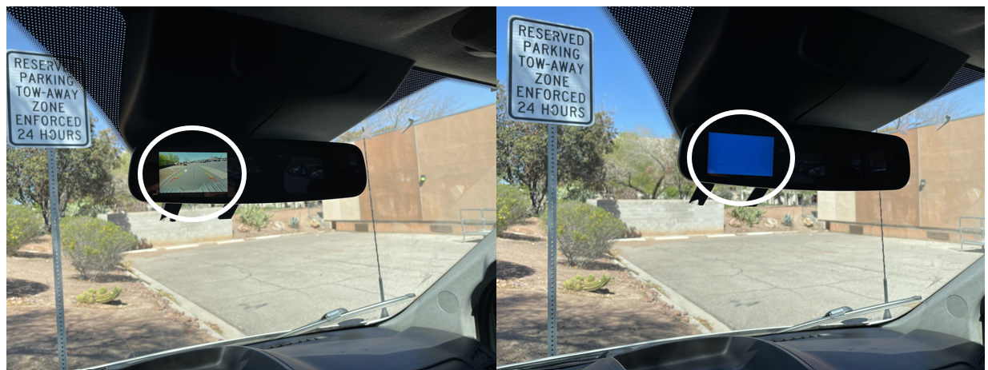

Fuel Tank Location:
The fuel door for the fuel tank is located on the driver’s side right underneath the driver’s door (circled in photos below). Leave the driver’s side door open and then you will be able to access the fuel door to flip it open. Close the fuel door first before closing the driver’s door.

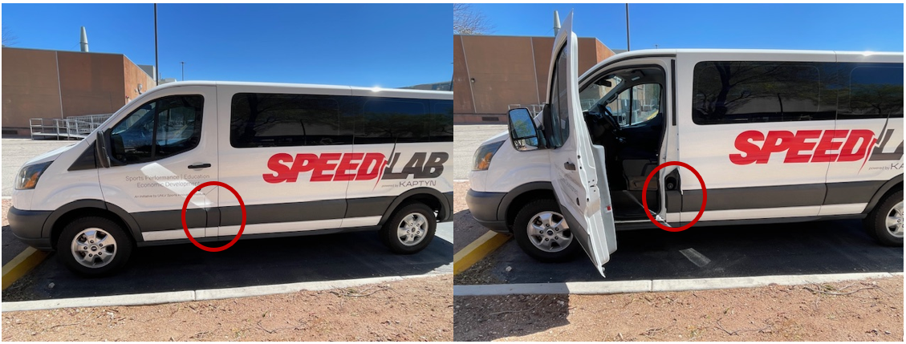

Using Fuel Card:
When using the fuel card that is provided for this vehicle, follow these instructions.
- While at the pump or cash register, swipe or insert the fuel card
- Next the screen will ask for the total miles currently on the odometer, enter that information
- Then it will ask for the driver’s ID number. A 6-digit number should be provided for you to use. (If for some reason you do not have a driver ID number available and you feel as if you do not have enough fuel to make it back to campus, please reach out to any of the emergency contacts that are provided)
- After you complete the steps above, you may fuel the SPEED Lab as you normally would.

Return Keys to Lock Box:
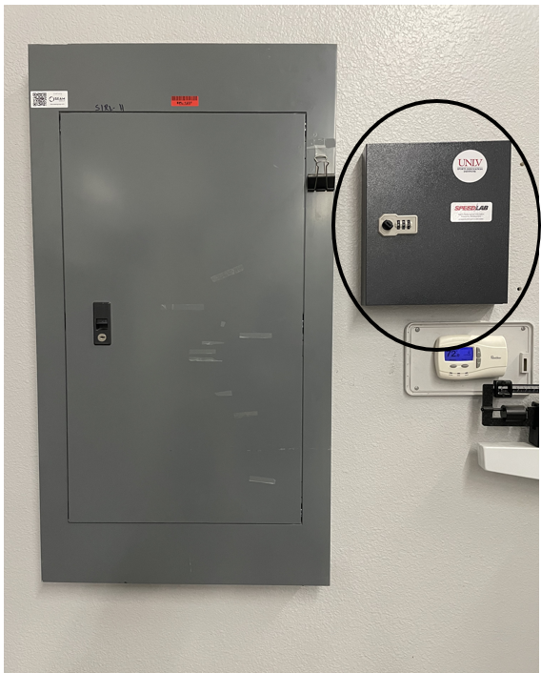
The keys to the SPEED Lab are stored in the lock box located inside the Biomechanics Laboratory. The Biomechanics Lab is in the Claude I. Howard Sports Injury Research Center (also known as MPE – G) and the room number is 102. The lock box is located right next to the breaker box inside the biomechanics lab (circled in the photo below). Once you have access to the lab, immediately look to your left upon entering and you will see the lock box. The code to the lock box is “725” and then turn the knob to the unlock symbol to open it. Then place the keys back inside on an available hook, close the door, turn the knock back to the lock symbol, and scramble the code to ensure the box is indeed locked.

Car Wash:
We understand that having a dirty car can be an eyesore. If you feel the SPEED Lab is unnecessarily dirty, DO NOT take it through an automated carwash. Due to the size of the van, many automated carwashes are not capable of comfortably support the van without the possibility of exterior damage. The SPEED Lab should be handwashed only if or when wash is needed.
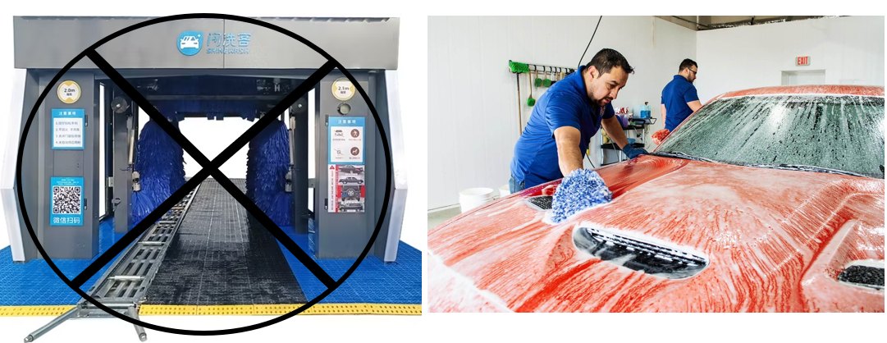

Removing/Replacing Bench Seats:
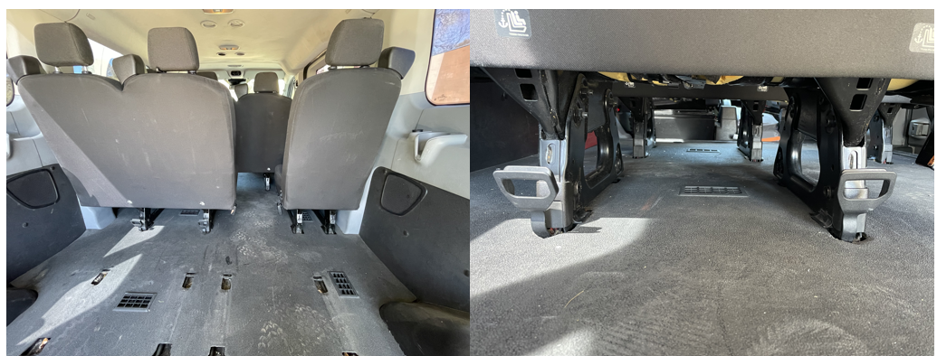
You can remove the back two row bench seats if you need more space. To do so, pull the 2 latches up simultaneously and push the back of the bench forward and unhook the seats from the floor. To replace the seats, correctly place benches back inside the van in their correct position and make sure they are properly secured and hooked to the floor of the van.

12-Volt Power Outlets and USB Cables:
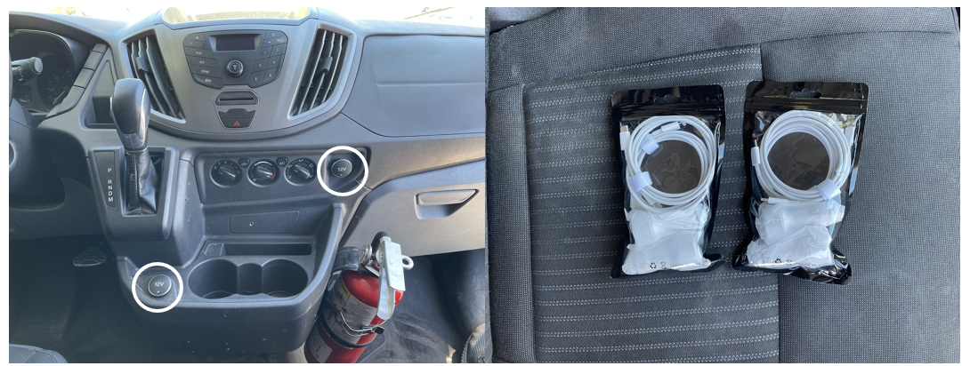
There are two noticeable 12-volt power outlets in the front center console of the SPEED Lab (circled below). Inside the SPEED Lab should be a total of 2 car chargers with 4 separate cables (2 USB lightening cables, 2 USB-C cables). You should be able to use both charging outlets simultaneously if you need to.

AED & First Aid Location:
The AED & First Aid kit will be stored in a plastic bin only for that. The plastic bin with the AED & First Aid kit should always be easily accessible. Due to the extreme weather conditions, the AED and First Aid kit will be stored in the Biomechanics Lab when the SPEED Lab is not in use. Make sure the plastic bin containing the AED & First Aid kit is always in the SPEED Lab before you ever take it out for any event!
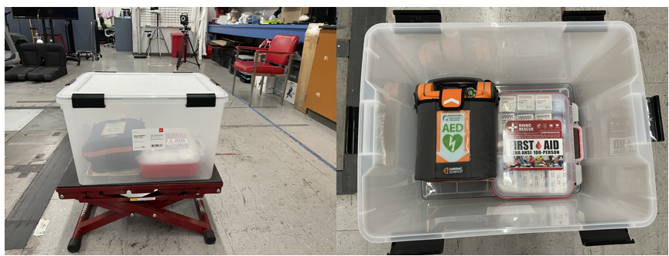
Flat Tire:
If you have a flat tire in the Las Vegas area during normal business days Monday – Friday from the hours of 7:30 am – 4 pm, UNLV vehicle services can come out to help. The number for the UNLV vehicle services is (702) 895-3186.
If no spare tire is available, an incident occurs outside of regular business hours, or a flat occurs outside of the Las Vegas area then you will need to call for Roadside Assistance at your own convenience.
SN: If you ever need to put air in the tire, the pressure should not exceed 93 PSI
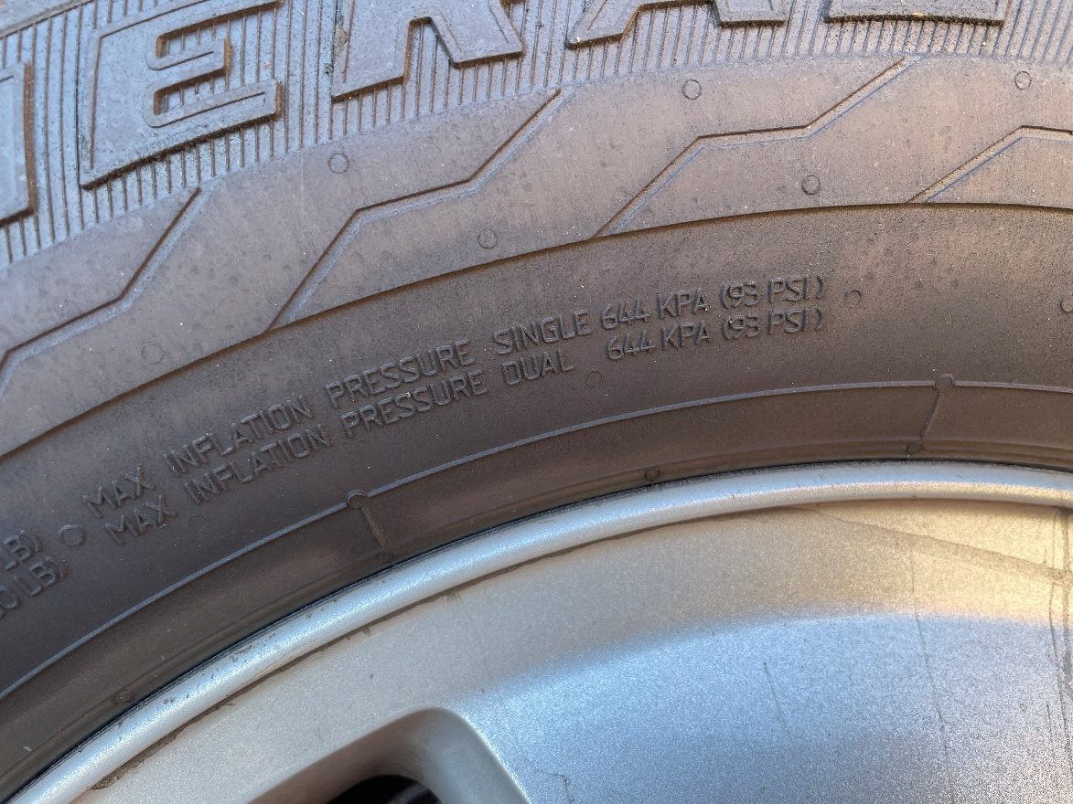

Accident Procedures:
In case of an accident do not leave the scene until the authorities have arrived. If medical attention is needed, then call 911 immediately! If no medical attention is needed, please contact the proper authorities. Contact the SPEED Lab Coordinator to notify them of the accident. There is an “Incident Report Form” (see below) for the SPEED Lab, please locate it and fill it out and have it ready to give to the SPEED Lab Coordinator.
